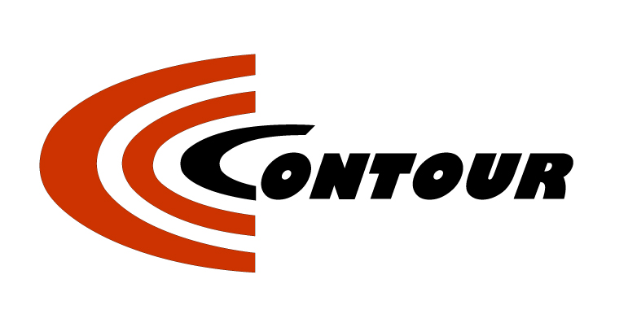
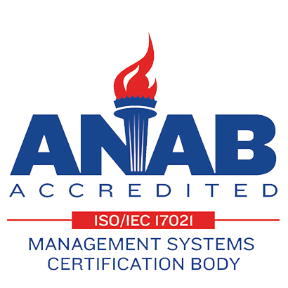

Contour Machine Ltd.
Sheet Metal Fabrication Specialists
NEW ARRIVAL!!
Contour Machine Ltd. is proud to announce that we have added an LVD Phoenix FL-3015 6K Watt Fiber Laser complete with Flexible Automation (FA-L) automatic load/unload system. This will complement our existing Amada FO 3015 M2 NT, and Amada LC2415 lasers to better serve our customers laser cutting demands.

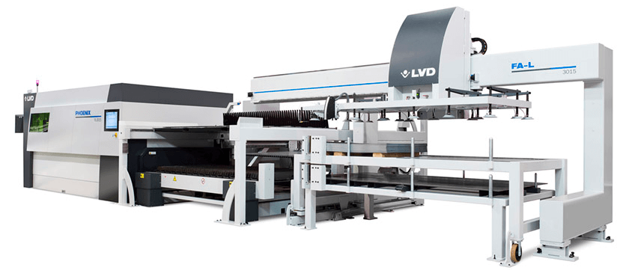
The Phoenix fiber laser cutting machine is an all-around performer. It has the flexibility to expertly cut standard steels and non-ferrous materials in a range of thicknesses and combines high machine dynamics, intuitive machine operation, and advanced automation options to maximize productivity no matter the application. The inherent benefits of fiber laser technology make Phoenix cost effective to maintain and operate.
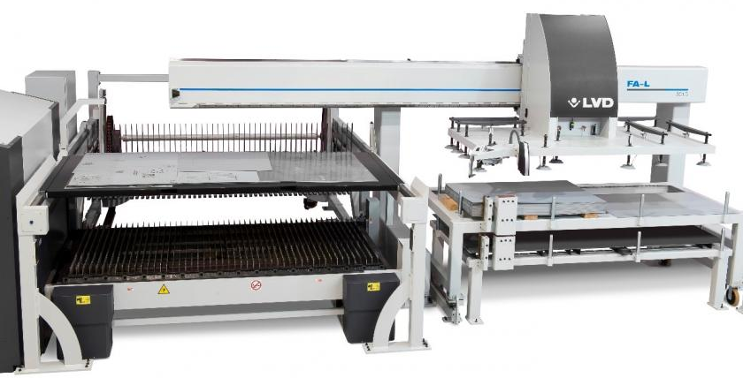

The LVD Phoenix FL-3015 6K Watt Fiber Laser can process ferrous and non-ferrous materials, including copper and brass as well as different sheet thicknesses without manual intervention. The advanced cutting head handles thicker materials and “On the fly” cutting in light gauge material. An integrated Siemens CNC control and drive system offers high reliability. The TOUCH-L touch screen graphical user interface control is intuitive and simple to use. An Automatic shuttle table maximizes uptime. The feed tables can load up to 120″ x 60″ (3000 x 1500 mm) size sheets.
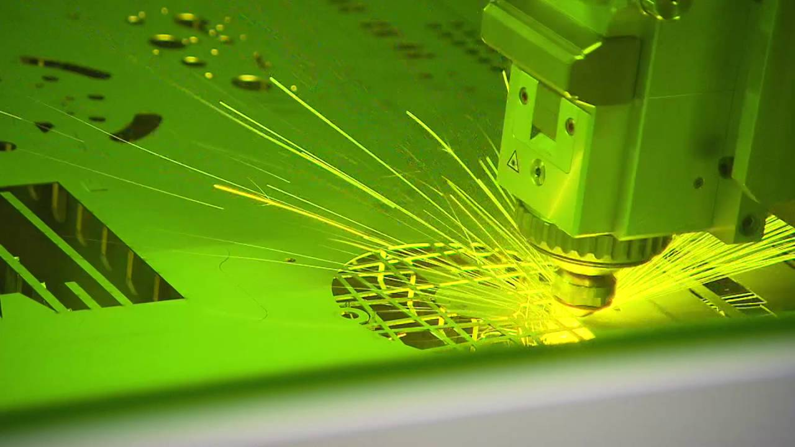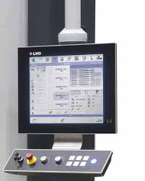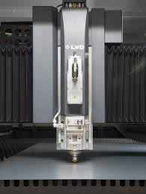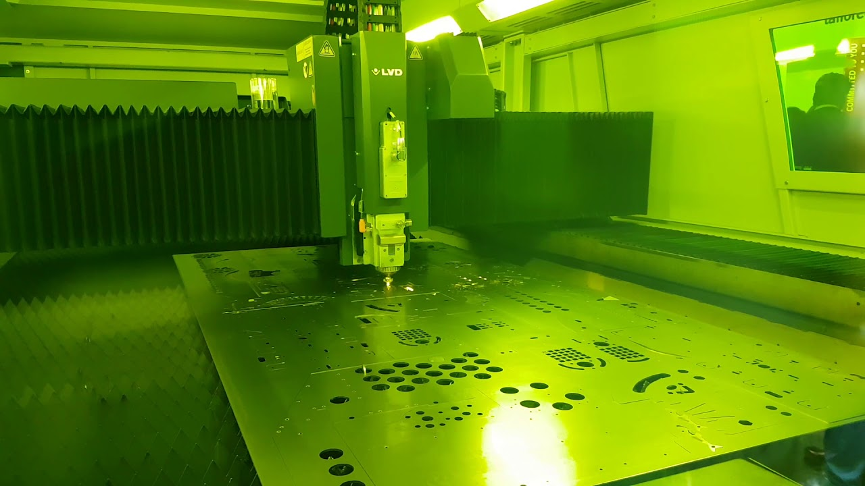
The FLEXIBLE AUTOMATION (FA-L) high-speed, automatic load/unload system eliminates manual sheet handling and increases machine productivity and efficiency. It can unload a processed sheet and load the next sheet onto the shuttle bed in just 40 sec. It is ideal for large volume applications with common material type, thickness, and size and for handling oversized or heavy work pieces.

Cutting capacities up to: 1" MILD STEEL, 1" STAINLESS, 1.18" ALUMINUM

Please contact us for more information or if you have any items you would like competitive quotations on.

120 Toro Rd North York Ontario M3J 2A9 John Baxter- President jbaxter@contourmachine.com
Tel (416) 747-7997, Fax: (416) 747-8491 Rob M Zakojc- Technical Sales Robz@contourmachine.com
Web: www.contourmachine.com

